Project Design Phase
Solution Architecture

Date | 29 September 2026
Team ID | SWTID-2026-2251
Project Name | AI FAQ Assistant
Maximum Marks | 4 Marks

Solution Architecture:
Solution architecture is a complex process – with many sub-processes – that bridges the gap between business problems and technology solutions. Its goals are to:
- Find the best tech solution to solve existing business problems.
- Describe the structure, characteristics, behavior, and other aspects of the software to project stakeholders.
- Define features, development phases, and solution requirements.
- Provide specifications according to which the solution is defined, managed, and delivered.

Example - Solution Architecture Diagram:

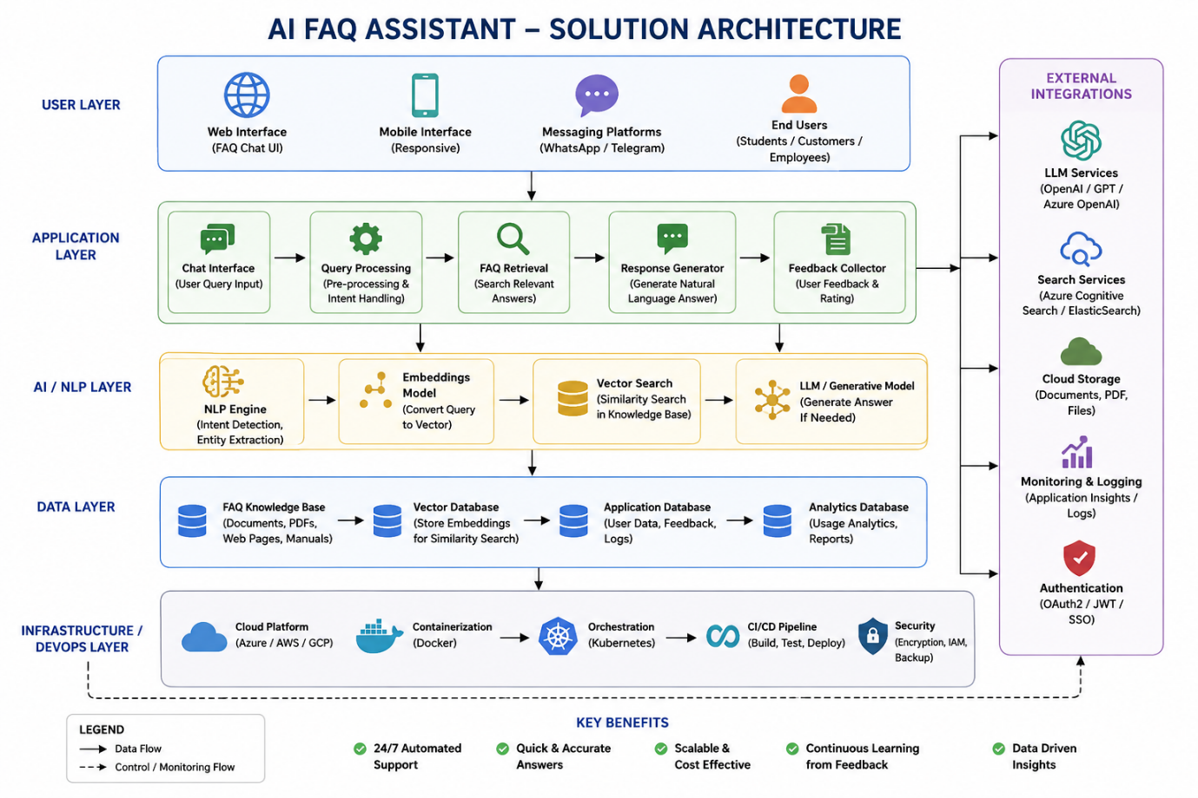
Figure 1: Architecture and data flow of the voice patient diary sample application
Reference: https://aws.amazon.com/blogs/industries/voice-applications-in-clinical-research-powered-by-ai-on-aws-part-1-architecture-and-design-considerations/

Completed Solution Architecture – AI FAQ Assistant
Architecture Flow
Layer | Component | Responsibility | Flow
1 | User / Client | Sends requests and receives API responses. | Client → API
2 | Express REST API | Routes requests to middleware/controllers. | API → Middleware/Controller
3 | JWT Middleware | Verifies tokens for protected endpoints. | Token → Middleware
4 | Controllers | Handle authentication, FAQ and AI business logic. | Controller → Model/Service
5 | MongoDB | Stores Users and FAQs. | Controller ↔ MongoDB
6 | Gemini AI Service | Generates AI answers and FAQ content. | Controller → Gemini → Controller
7 | JSON Response | Returns success/data/error to client. | Express → Client
Architecture Diagram (text): USER/CLIENT → EXPRESS REST API → JWT AUTH MIDDLEWARE → CONTROLLERS → MONGODB. AI requests additionally flow CONTROLLERS → GEMINI AI SERVICE → AI RESPONSE → EXPRESS → USER.

